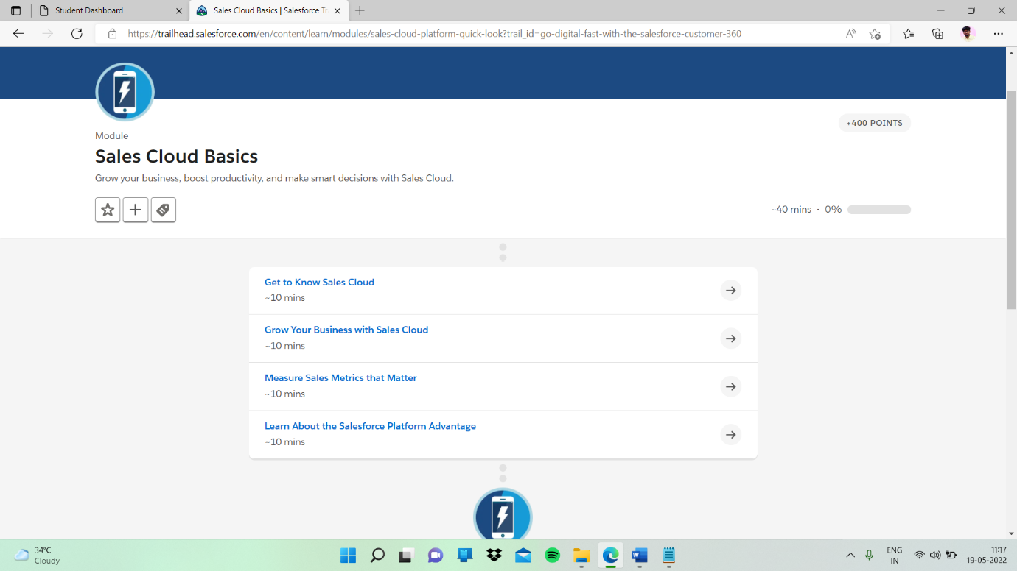

Sub topic:- Grow Your Business with Sales Cloud

In this given quiz and I completed

